SettingUpApplicationEnvironment

**InstallIBMCloudCLI**

|  |  |
| --- | --- |
| Date | 10 November 2022 |
| Team ID | PNT2022TMID50435 |
| ProjectName | SmartFashionRecommender Application |
| TeamMembers: | TAMIL SELVAN  ARUNVIGNESH  MATHESH  MOSAI |

# Step1:

LogintoyourIBMCloud***<https://cloud.ibm.com/login>***andin-searchbaryoucantype

**Containerregistery** andclicktogetstarted.

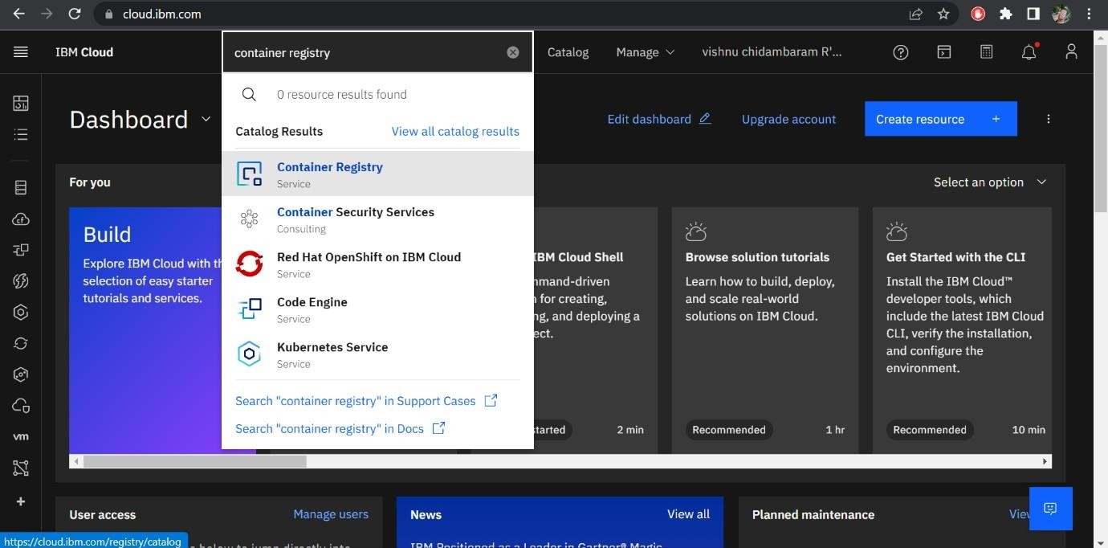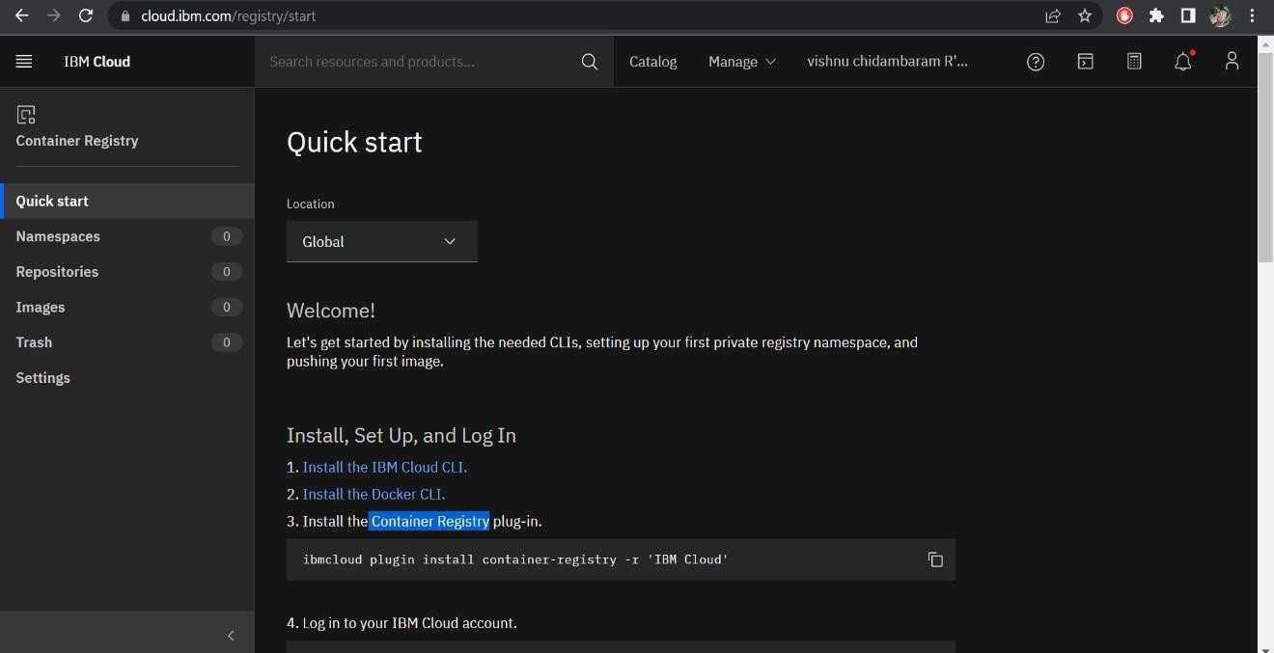

# Step2:

Followand dothestepgiven inthispageonebyone***[https://cloud.ibm.com/registry/](https://cloud.ibm.com/registry/%20start)***

[start](https://cloud.ibm.com/registry/%20start)

# Step3:

Runthecommandin powershell,

(New-ObjectNet.WebClient).DownloadString('https://clis.cloud.ibm.com

/install/powershell')

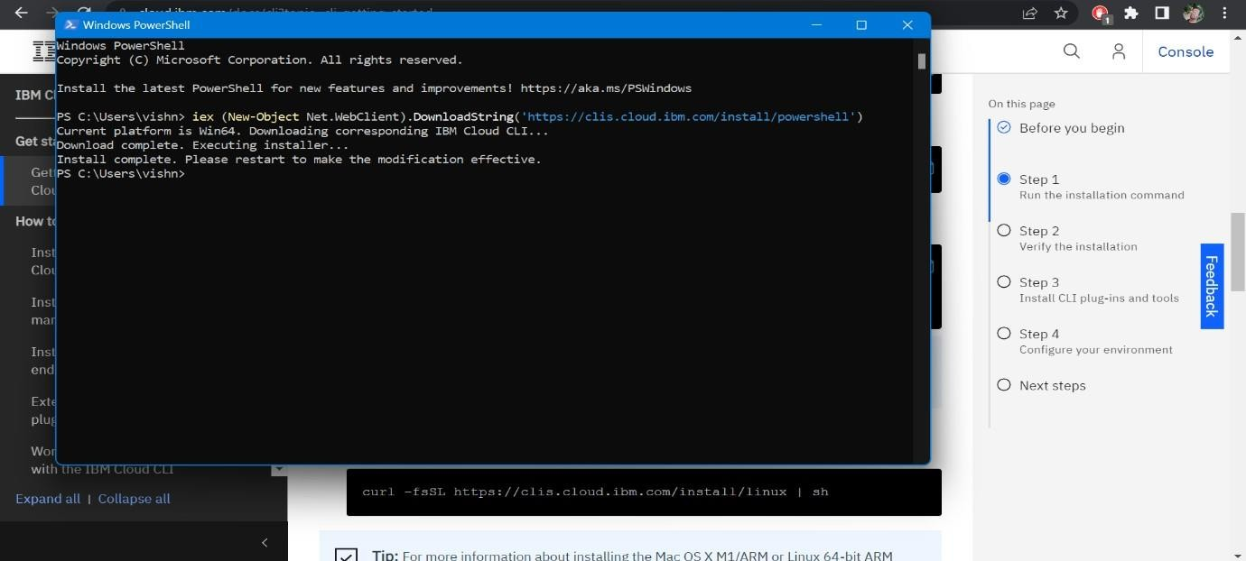

# Step4:

Enterthecommandincmd:

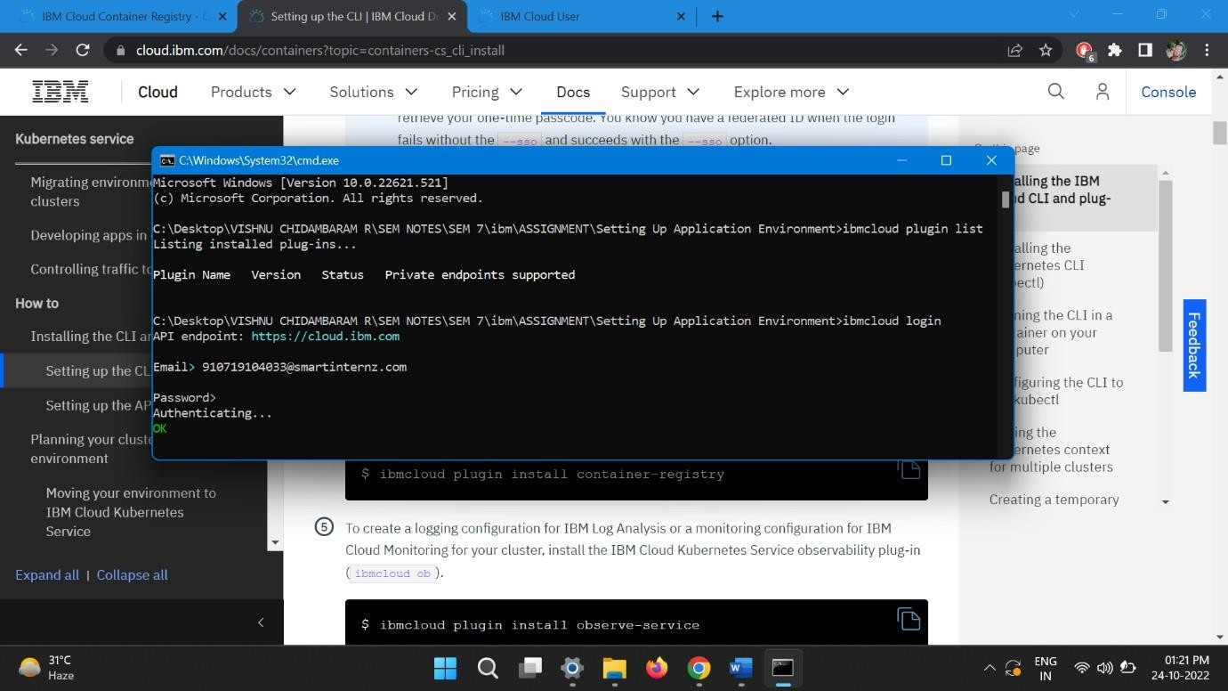

# Step5:

Runallthecommandonebyoneincmd

<https://cloud.ibm.com/docs/containers?topic=containers-cs_cli_install>

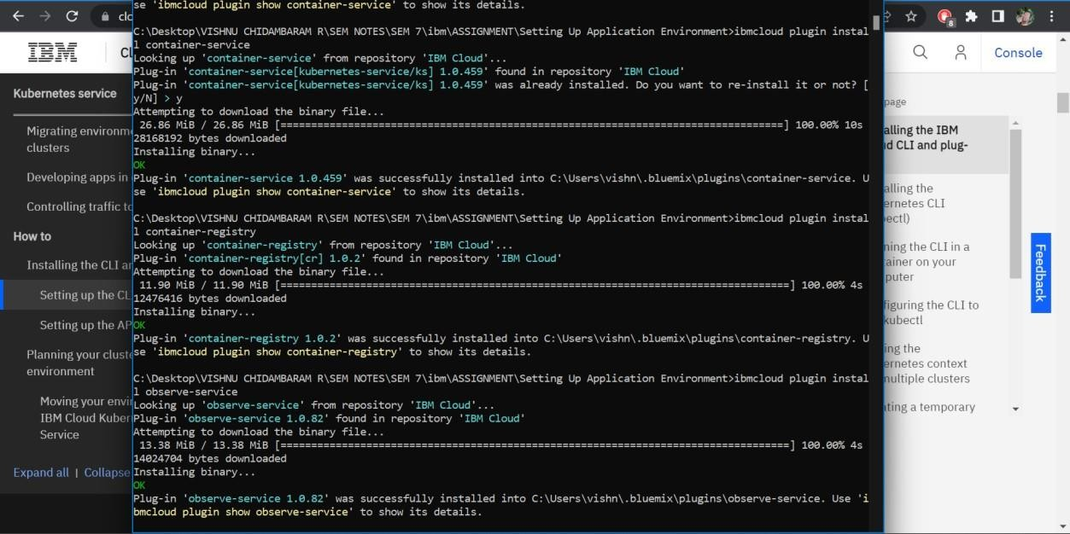

# Step6:

Finally,youwillgettheIBMCLOUDCLIinyourdesktop